PART 2 STARTS HERE

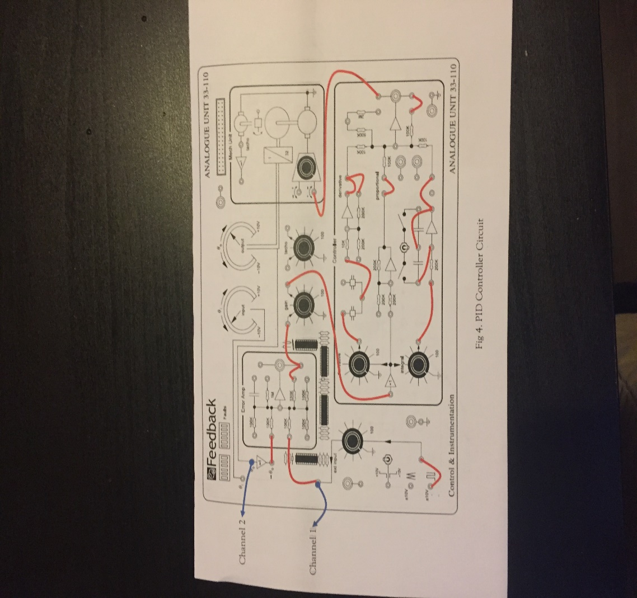
Figure 4. PID controller
P1 was established at one hundred percent, the P3 at fifty percent gain, the P5 at zero percent. On the other hand, the input frequency was established at 0.1 Hz. P5 and P5 percentage gains were established by the use of trial and error method to come up with the finest setting.

Results:

Observation 1:
The figure below is affiliated to observation one that is also the derivative block. As expressed in figure 5, signal transmitting was commenced by the triangular wave channel one.

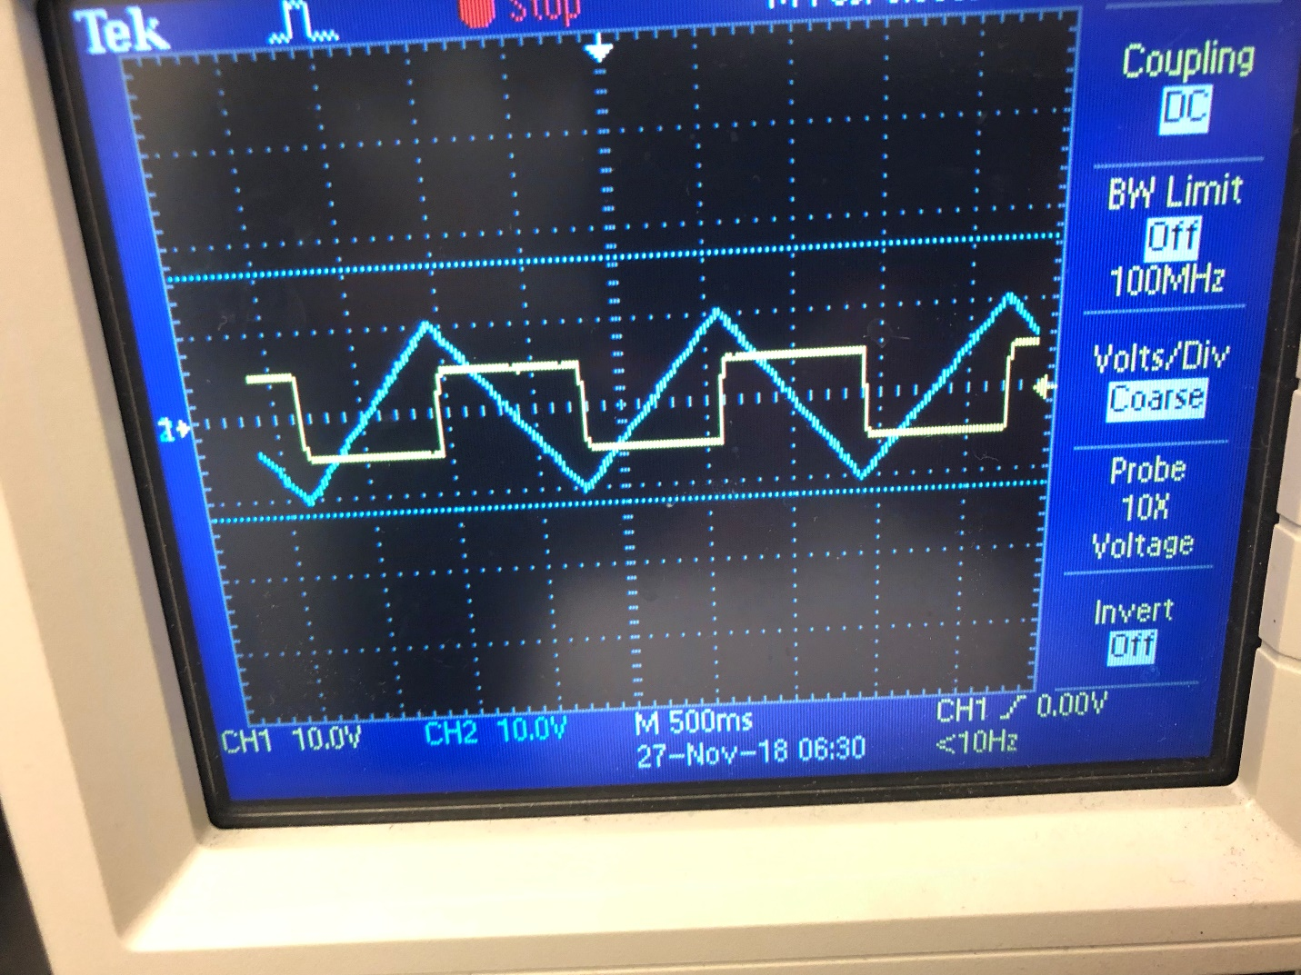
Figure. 5. Triangular wave
As expressed in figure 5, signal transmitting was commenced by the triangular wave channel two.

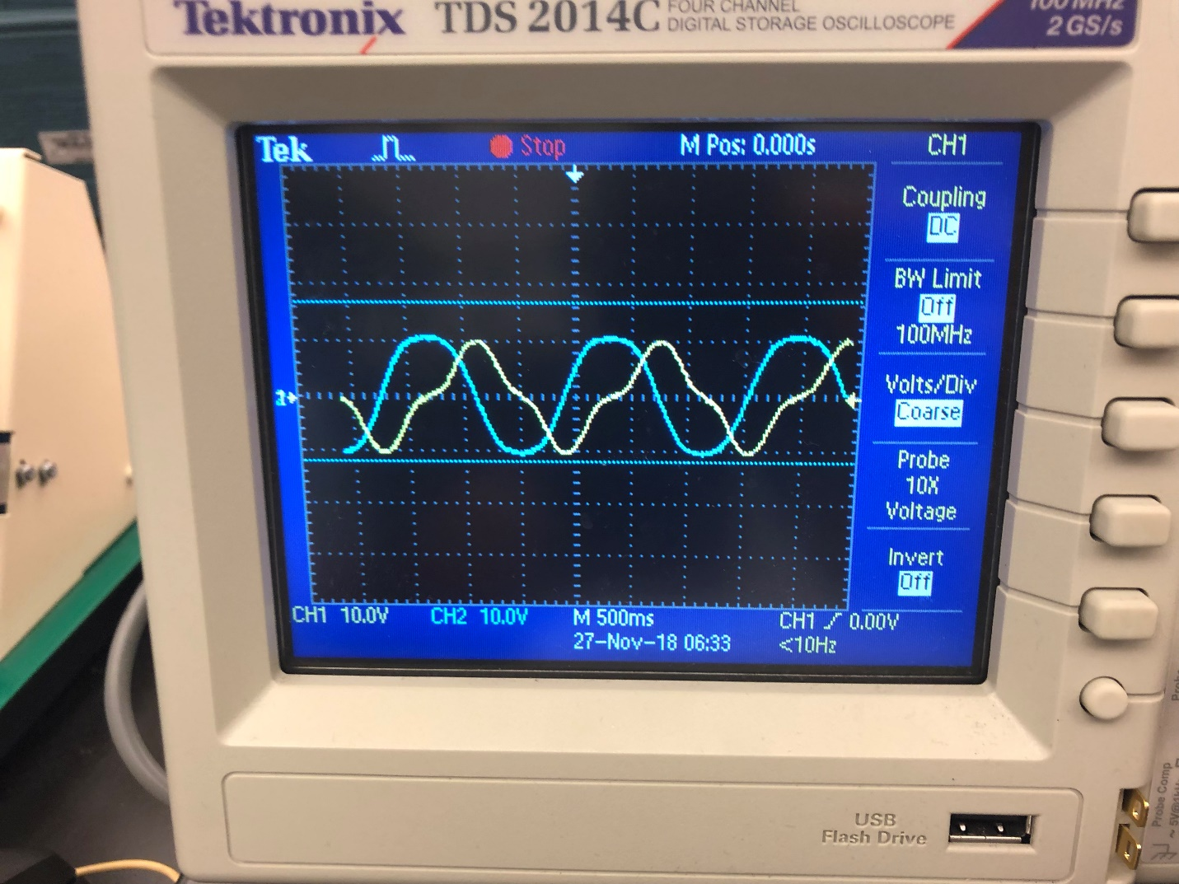Figure. 6. Sinusoidal wave channel 1

As expressed in figure 6, Signal was introduced by sinusoidal wave channel two.

Observation 2:
The figures below are affiliated to observation two that is also the integrator block. As expressed in figure 7, signal transmitting was introduced by square wave channel one.
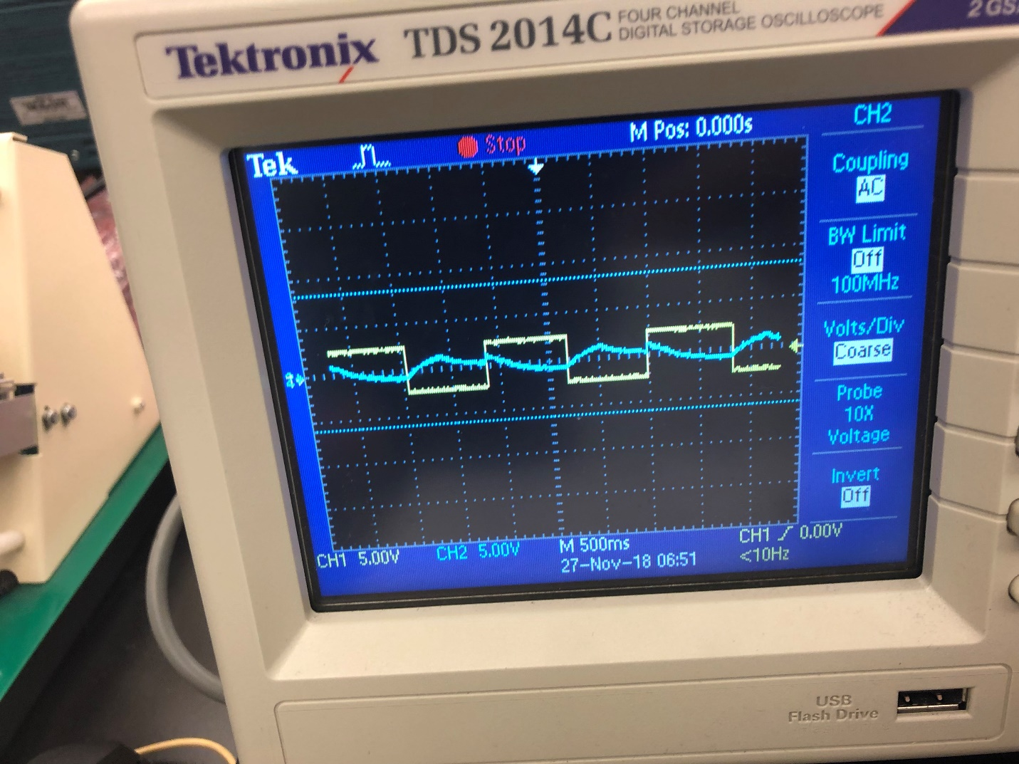
Figure 7. Square wave channel 1

As expressed in figure 8, signal transmitting was introduced by triangular wave channel two.
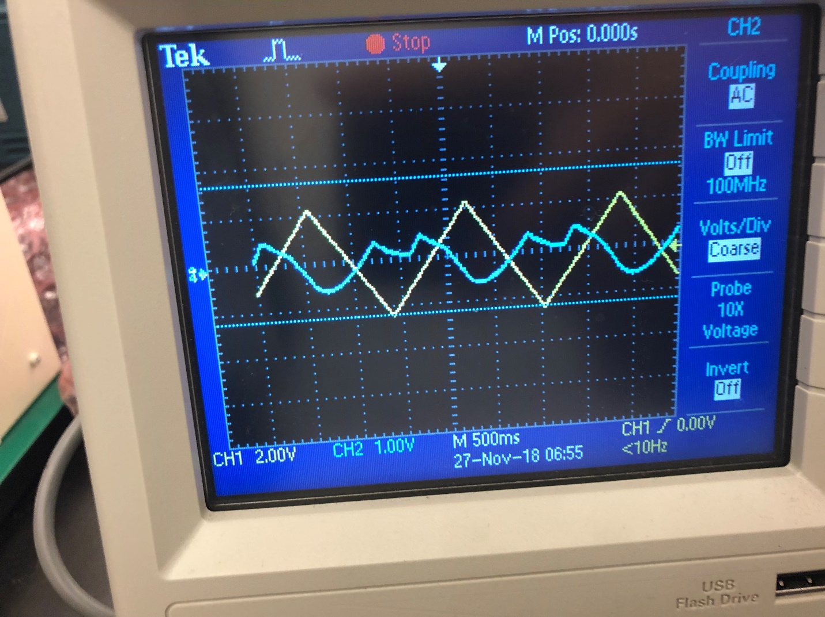
Figure. 8. Triangular wave channel 2

PD Controller:
The following figures are associated to PD controller.

